# Student Funding

# **Guide to completing our Childcare forms**

# Academic Session 2025-26

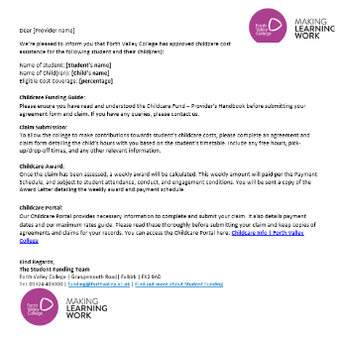Once the student has been awarded funding for childcare, you will receive an email from [funding@forthvalley.ac.uk](mailto:funding@forthvalley.ac.uk) which contains information in relation to the student and the child you will be caring for. This email will contain basic information in relation to the student’s award, links to the claim forms and guides and brief information in relation to claim submission, award and links to our online portal.

Where possible please **download and save copies** of the childcare agreement, weekly claim form, ad hoc and amendment claim form for your records. The forms should be filled in with the necessary details and returned to us completed as an attachment. You may need to save the files before editing, so we recommend saving prior to filling in. Please be aware that if you are caring for more than one student’s child/ren, please wait for each students award email before submitting paperwork.

* Within the award email, you will be provided with a link to access the Childcare Funding Provider Handbook. We strongly recommend you **read this prior to filling in any of the following forms**, the handbook has been built around frequently asked questions and so should provide you with the necessary information required to complete each of the forms.
* It is vitally important that, prior to filling in the claim form, you receive a copy of the students timetable and cross reference this when completing the forms, as the college will not provide funding for the days the student is not attending college or associated work placement.

## Forth Valley College Childcare Provider Portal



To download each file, click on the name of each file which will open up your web browser. You should now have open a web version of Microsoft 365.

If you are using the web version of Microsoft 365: Sign in to your Microsoft account to be able to edit online by double clicking the form.

If you have access to your own version of excel, at this stage, you can download the file. Once opened in excel, please ‘edit the copy’ and save to your files. 



## Childcare Agreement and Claim Form

### Agreement

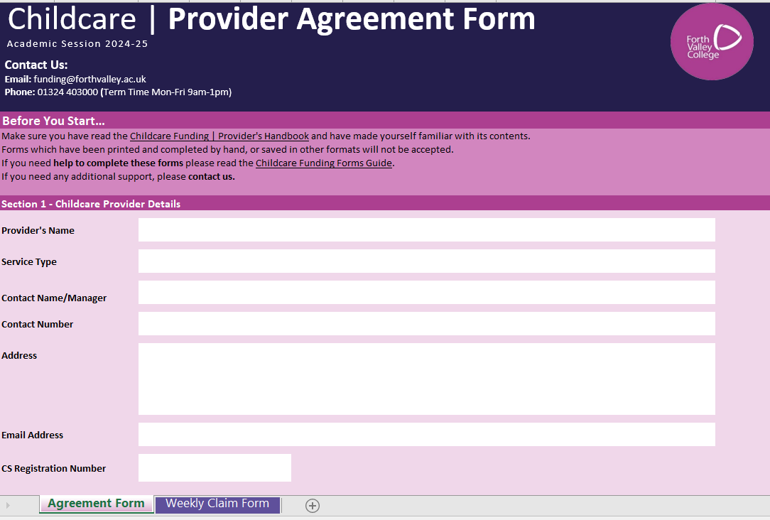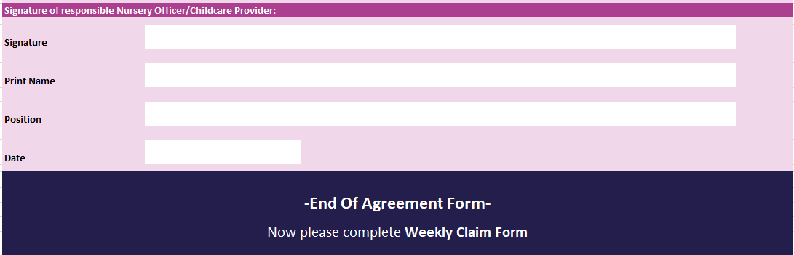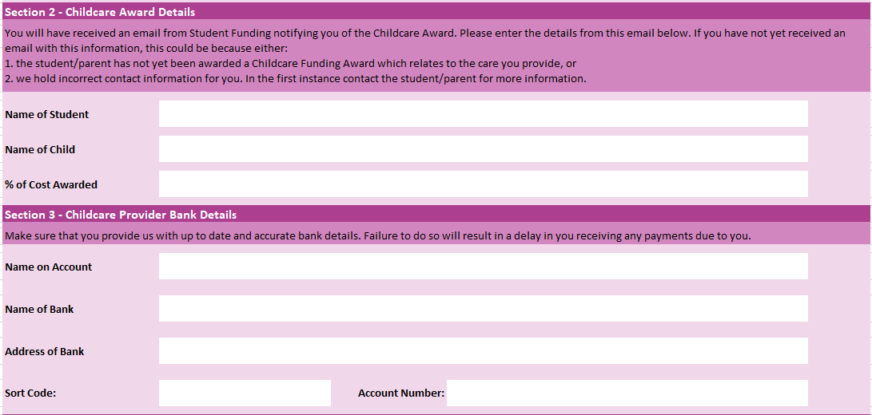

The agreement form can be found on the first tab within the weekly claim form file. It is essential that this is filled in fully, and the terms and conditions are accepted prior to the release of funding.

**Section 1** – Input all of your establishment’s details including name, address and CS number. Please note the “service type” box is a drop down meu, please click on the white box and select what kind of care you are providing for the child.

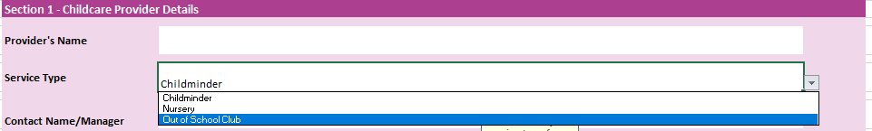

**Section 2** – Input details of parent (FVC student) and child as well as % of cost awarded. This will be found on the original award email sent to you.

**Section 3** – Provide your bank details in here, please double check the bank details provided. We **do not** verify the accuracy of bank details, we complete a test run shortly before the payment is made, however this only highlights if the payment fails and not whether the account details are accurate.

**Section 4** – Please read the terms and conditions carefully and sign your details at the bottom if you are happy to proceed.

## Childcare Agreement and Claim Form

### Weekly Claim

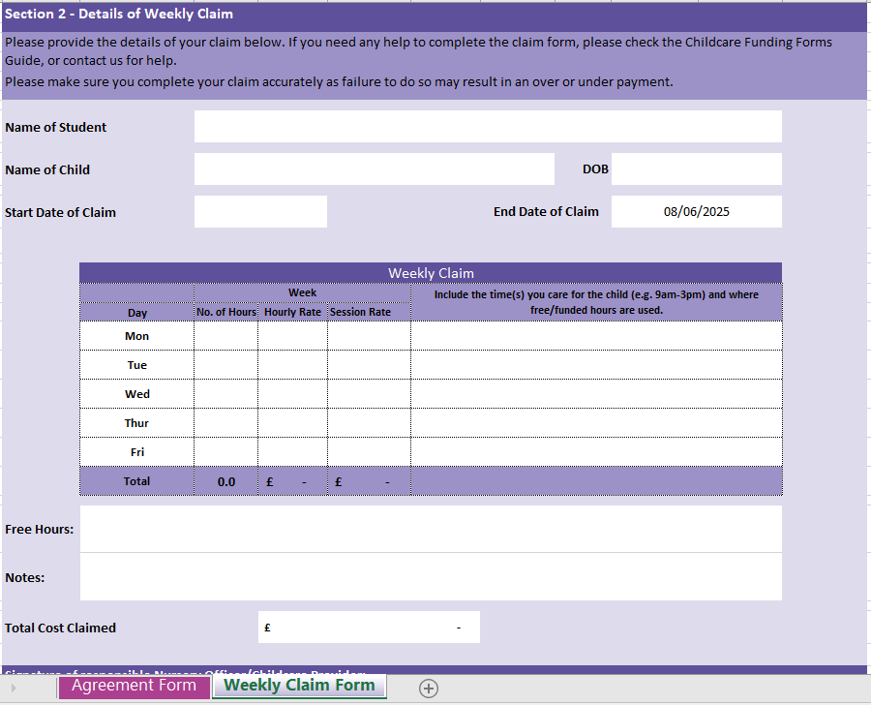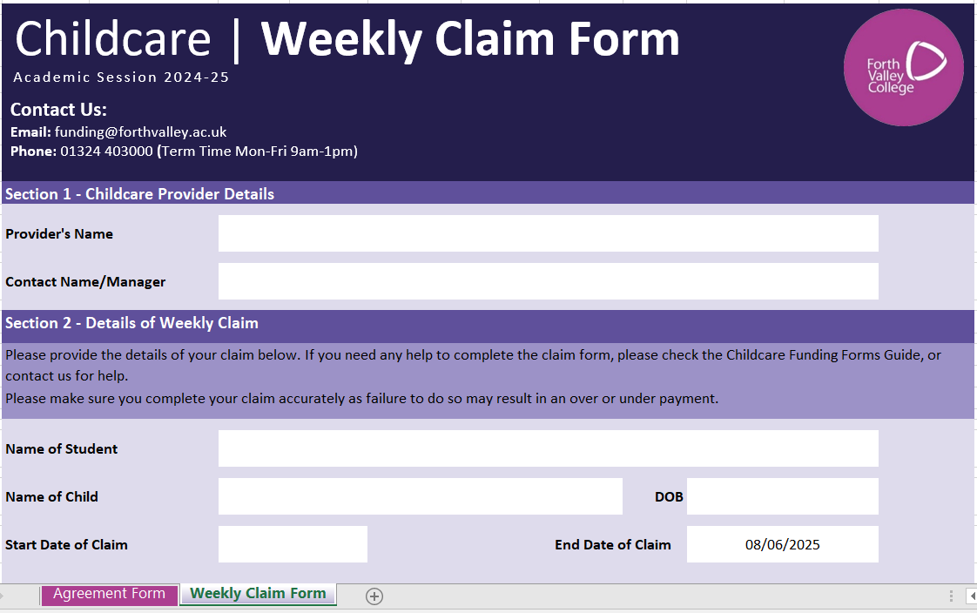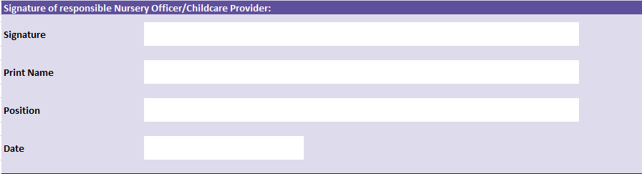

The weekly claim form can be found on the second tab within the weekly claim form.

**Section 1** – Input your establishment’s details including the registered name and main contact details.

If you require space to detail any notes, please use the space allocated below “Notes”.

Depending on whether you charge per hour or by a set session rate, fill in the each day to reflect this. The “No. of Hours” is a drop down menu.

If you charge by hour, enter the number of hours the child is in your care as well as hourly rate, the totals will update accordingly along the bottom.

If you charge by the session, please enter number of hours the child is in your care and session rate.

Please note, students are permitted to claim one additional hour each side of their timetabled/scheduled classes or work placement to allow for travel time.

**Section 2** – Fill in the name of the student and child who will be in your care, the child’s date of birth and start date of the claim. The end date of the claim will already be filled in and generally, this will be the end date of term, unless otherwise specified. Please only edit this date if you know you will stop providing childcare before the end of term.

Sign and date the form before sending over to [**funding@forthvalley.ac.uk**](mailto:funding@forthvalley.ac.uk)

Your Digital signature is recorded and verified by you submitting these to us from your email address that we have on file.

At this stage we will require you to submit your official rate sheet detailing the cost(s) for your services before we can process your claim form.

If you require additional space to details free hours, please use the space allocated here.

**Please note at the end of this guide, you will find practical examples to assist you in completing the form, should you require assistance.**

## Amendment claim Form

The Amendment form is to be used when there is a need for a permanent change to the care you provide, such as a timetable change.

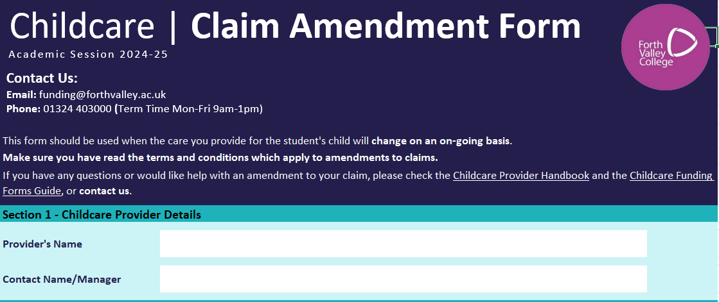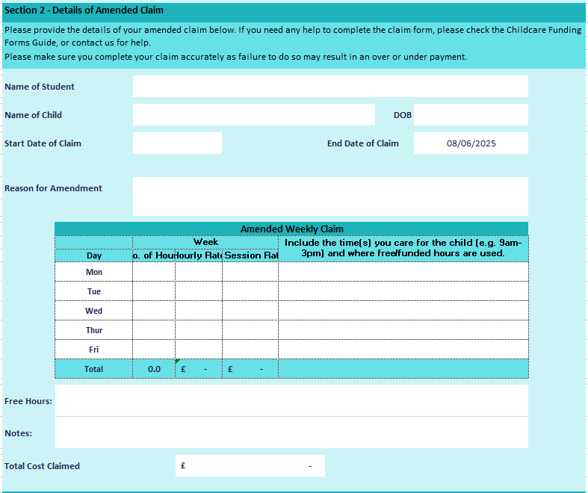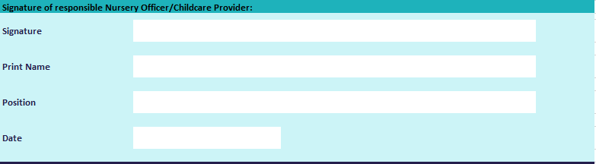

We ask that the amendment form is completed and sent to us within 6 weeks of the change. Claims submitted after the 6 week period will not be backdated.

**Section 1 –** Input your establishment’s details including the registered name and main contact details.

**Section 2** – Fill in the name of the student and child who will be in your care, the child’s date of birth and start date of the claim. Please note the start date of the amended claim form. The end date of the claim will already be filled in and generally, this will be the end date of term, unless otherwise specified. Please only edit this date if you know you will stop providing childcare before the end of term.

Please note the reason for change in the allocated box below.

Depending on whether you charge per hour or by a set session rate, fill in the each day to reflect this. The “No. of Hours” is a drop down menu.

If you charge by hour, enter the number of hours the child is in your care as well as hourly rate, the totals will update accordingly along the bottom.

If you charge by the session, please enter number of hours the child is in your care and session rate.

Please note, students are permitted to claim one additional hour each side of their timetabled/scheduled classes or work placement to allow for travel time.

 Please ensure that you complete the amended weekly claim form for the entire new week you are claiming, rather than just for the change in childcare.

If you require space to detail any notes, please use the space allocated below “Notes”.

If you require additional space to details free hours, please use the space allocated here.

Sign and date the form before sending over to [funding@forthvalley.ac.uk](mailto:funding@forthvalley.ac.uk)

Please note that we may ask for **additional evidence** to coincide with the amended claim:

* The nursery is unable to provide care due to limited available spaces (child is entitled to free hours). There is now a need for a childminder to be utilised in the meantime - Evidence from the nursery explaining this would be required.
* Change to timetable - we will confirm with students timetable or department.
* Change to placement days - we will confirm with students timetable or department.

## Ad hoc claim form

The Ad hoc claim form is to be used when there is a need for a one off change to the care you provide, such as a school strike day or in-service day.

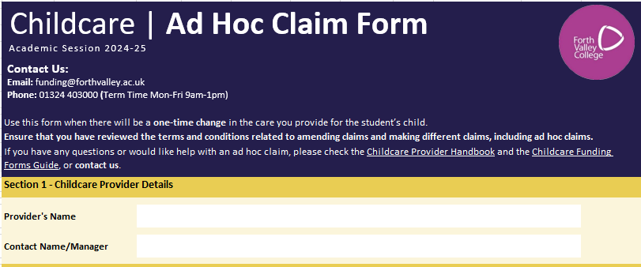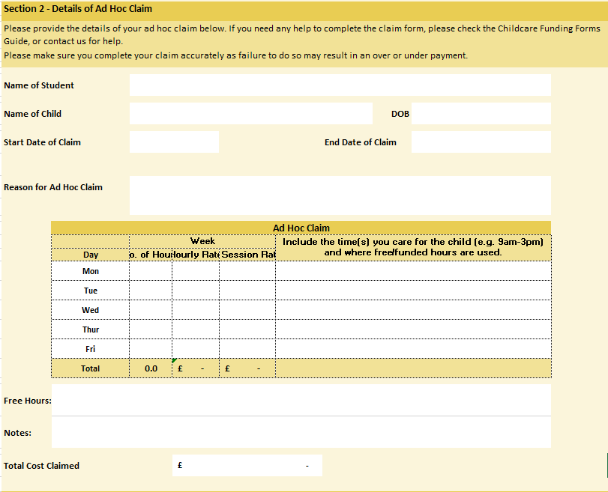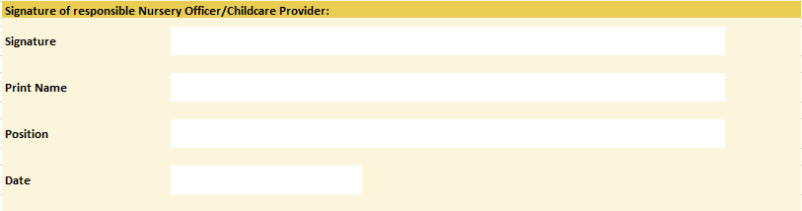

We ask that the ad hoc form is completed and sent to us within 6 weeks of the change. Claims submitted after the 6 week period will not be backdated.

**Section 1 –** Input your establishment’s details including the registered name and main contact details.

**Section 2** – Fill in the name of the student and child who will be in your care, the child’s date of birth and start date of the claim. Please note the start and end date of the ad hoc claim form.

Please note the reason for ad hoc claim in the allocated box.

Depending on whether you charge per hour or by a set session rate, fill in the each day to reflect this. The “No. of Hours” is a drop down menu.

If you charge by hour, enter the number of hours the child is in your care as well as hourly rate, the totals will update accordingly along the bottom.

If you charge by the session, please enter number of hours the child is in your care and session rate.

Please note, students are permitted to claim one additional hour each side of their timetabled/scheduled classes or work placement to allow for travel time.

Sign and date the form before sending over to [funding@forthvalley.ac.uk](mailto:funding@forthvalley.ac.uk)

If you require space to detail any notes, please use the space allocated below “Notes”.

If you require additional space to details free hours, please use the space allocated here.

Please note that we may ask for **additional evidence** to coincide with the ad hoc claim:

* There is an in service day at the school that the students child attends - Confirmation from the school, newsletter or other official evidence detailing this.
* School holidays that do not match with Falkirk Council (October week) - School newsletter/ Screenshot from relevant council website.
* Block Week - we will confirm with students timetable or department.

# Worked examples:

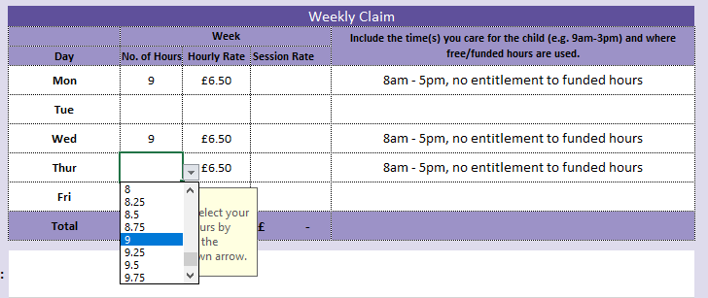**Example 1**

Below is an example of a childcare claim for a student who attends college 9am - 4pm on Mondays, Wednesdays and Thursdays. The childcare provider charges hourly and the child is 1 year old.

**Example 2**

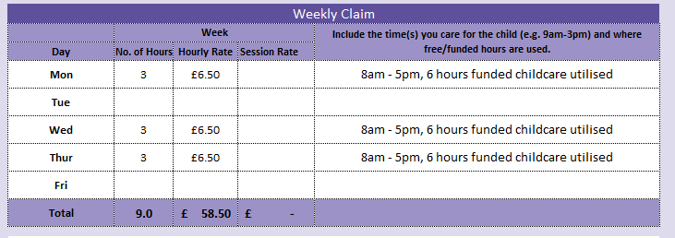

If the child you are providing care for is entitled to funded hours (i.e. eligible two or aged 3-5 [1140 funding]) please deduct these from the number of hours claimed. The following example shows a claim for a student who attends college 9am-4pm Monday, Wednesday and Thursday. The student utilises their full entitlement to funded hours across 5 days, i.e. the child attends nursery 8am – 5pm Mondays, Wednesday and Thursdays and 9am-3pm Tuesdays and Fridays.

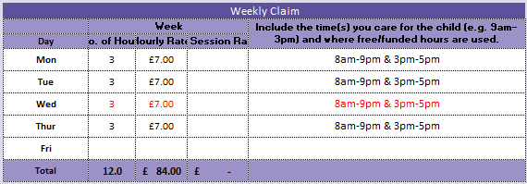

**Example 3 - Deductions**

In this example, deductions are made based on the timetabled days the student attends college. Specifically, Mondays, Tuesdays, and Thursdays are considered timetabled days. As a result, Wednesdays would not be payable. The cost for Wednesdays is deducted from the total claim, making the student liable for this expense.

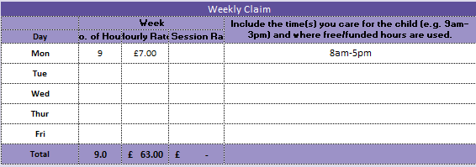**Example 4 - Deductions**

This scenario illustrates how deductions are calculated based on our fee caps. The provider has claimed 9 hours at £7 per hour, resulting in a total of £63 per day. However, our fee cap is a maximum of £60 per day. As a result, the student would be responsible for the remaining £3 each week*.*

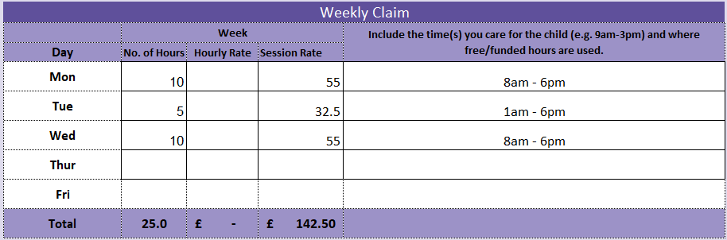**Example 5 – Deductions**

This scenario illustrates how deductions are calculated based on the percentage of childcare awarded, in this case 75%.

The provider has claimed based on the students timetable which is within our daily fee caps.

We will deduct the 25% for which the student is responsible. The college will contribute £106.88, and the student will be responsible for the additional £35.62 each week.