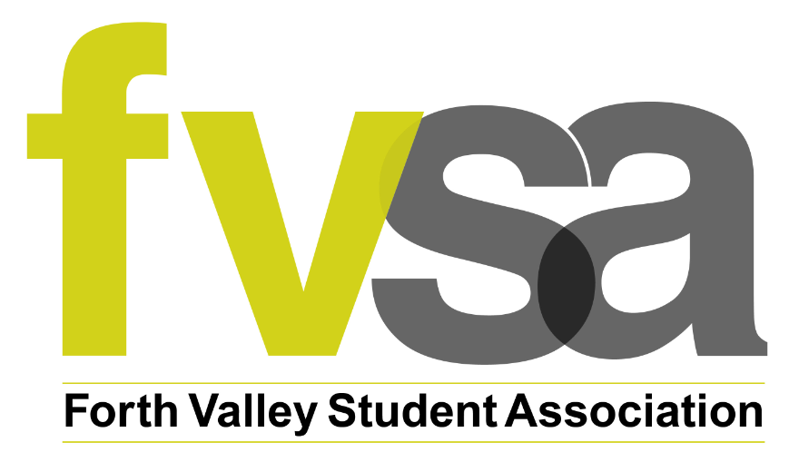

Election Guidebook

Student President & Vice President Election

Term of Office: July 2026 – June 2027

Contents

​​Introduction…………………………………………………………3

Forth Valley Student Association (FVSA)……………………..3

Being a Student President or Vice President Officer………………………………………...4

Positions …………………………………………………5

- Student President and Vice President……………………..6

What do I do now? ....................................................................8

Key Dates …………………………………………………………....8

- Nomination &Advertising Opens ……………………….9
- Close of Nominations…………………………………….9
- Candidate Briefings……………………………………….9
- Campaign Begins/Voting Open………………………….9
- Results Verification & Announcement ………………….9

Contact Us……………………………………………………………..9

​
​
​
​
​
​

​

​
​
Introduction

Thanks for your interest in the Student President and Vice President roles!

This document will give you all the information you need to know about standing for election to the Student President and Vice President posts.

Forth Valley Student Association (FVSA)

FVSA plays a key role in ensuring Forth Valley College (‘FVC’) students’ opinions are sought, and represented, at all levels of College management.
As elected employees, the Student President and the Vice President:

- Seek the opinions of FVC students and represent them at various meetings,
- Work to achieve objectives assigned to them under various Action Plans and projects,
- Work to deliver on their manifesto goals

FVSA facilitates the collection of feedback from students, delivers engaging events, activities and Student Association functions, aiming for the student experience at FVC to be the best it can be.

Various staff members support the work of FVSA by carrying out essential tasks to ensure an effective Students Association is run in the interests of FVC’s students.

The FVSA team consists of 4 members of staff:

- Administrator
- Student Engagement Co-ordinator
- Student President
- Vice President

All staff are line managed by the Student Association & University Partnerships Manager, who is line managed by the Head of Learning & Teaching Enhancement.

All staff are encouraged to request guidance and support at any time, and staff have regular 1-2-1 meetings with their line manager to support their professional development and to stay on track with their objectives.

You will build positive working relationships with College staff who support the work of the FVSA e.g. Finance, IT, Moodle, Estates, Gym, Hospitality, Communications & Marketing, Academic. Working with others will help to build your knowledge and skills across many areas.
FVSA works out of offices which are located within all Forth Valley College campuses – Falkirk, Stirling, and Alloa.
You will be expected to work at each campus in accordance with the commitments of your role, team commitments, and the rota, and to engage all students in the work of FVSA regardless of which campus they study at.
To minimise travel, many meetings are hosted via MS Teams.

Office hours are Monday – Friday, 8.45am – 4.45pm (one hour lunch break).

Being a Student President/Vice President

Spending a year as a Student President/Vice President is a fantastic way to gain and develop a your skills. Standing for election is an experience you will remember for a long time.

It might seem like there are a lot of rules to follow, but there is plenty of room within the rules to deliver an election campaign which will engage your fellow students, and contribute to an overall positive experience for everyone involved.

You will be representing the views of over 13,000 students at FVC, while also being able to focus on achieving various objectives under Action Plans such as those linked to the Student Partnership Agreement, the Student Mental Health Agreement, and the team’s Operational Plan.

You’ll make a positive difference to the student experience at FVC, and if you’d like to have an impact on the national level you can get involved with the campaigns of the National Union of Students.

You will face many challenges and learn plenty of new skills, all of which will help you to find employment once you move on from the Student Association.

As well as attending important meetings such as Board of Management, the Student President and Vice President also support the delivery of events such as Welcome Fairs; encourage student engagement by working with lecturers to support students’ projects; and work on their manifesto goals. You’ll also be invited to sparqs and NUS events, and you’ll meet fellow Sabbatical Officers at other colleges and universities.

Your work will be varied, you’ll be supported by your colleagues. You’ll be involved in lots of projects, and no day will be the same!

Positions Available

Student President and Vice President

Role type: Part-time (0.4 FTE (14 hours per week)), fixed-term employment
Your pattern of work will be agreed to fit around the summer, and your Block 1 and Block 2 timetables. You may work a combination of full and half days to suit your timetable and other commitments. Flexibility will be afforded wherever possible for you to attend important College meetings, and carry out other requirements of your role, while also considering your studies. You will be encouraged to use annual leave throughout your term in office, including around assessment deadlines and exam periods.
Office hours are Monday – Friday, 8.45am - 4.45pm. On occasion, you will be required to work beyond office hours e.g. to attend a Board meeting which concludes at 6.30pm. You will know in advance of any late meetings.
Duration: One year – beginning of July 2026 to end of June 2027

Purpose: The Student President and the Vice President are FVSA’s key student representatives. The Student President has more responsibilities than the Vice President, therefore please note this is reflected in the salaries for each post. The Student President and Vice President roles are very similar, and share the majority of responsibilities. However, the following responsibilities are exclusive to the Student President role:

- The main representative, and spokesperson of, the FVSA
- The lead delegate at the NUS Scotland Conference
- The Chair of the Executive Committee
- Attends the majority of College Committee meetings
- Final decision on any Sabbatical discussion which requires a response
- The Student President leads on the Student Partnership Agreement (the Vice President leads on the Student Mental Health Agreement)

Please take into consideration these differences before deciding which post to stand for.

The Student President and the Vice President shall:

- Attend the Board of Management meetings, and other relevant College committees, to represent the student voice, and report back to the FVSA.
- Work with the National Union of Students to ensure the voice of FVC students is represented nationally.
- Encourage FVC students to get involved with and shape the work of FVSA.
- Work as part of a motivated team and encourage the Executive Committee members to work to the best of their ability.
- Draft the FVSA annual budget, be responsible for not over-spending and make all spending decisions in the interests of the FVSA and the students
- Coordinate FVSA work in response to the needs and opinion of the student body.
- Facilitate student engagement opportunities within the College including class visits, events, information gathering, and participation in Class Rep training and Student Council meetings.
- Support the FVSA Executive Committee by implementing partnership projects in conjunction with the College.
- Establish and maintain contact with offices in other colleges, universities and relevant organisations to identify and maintain best practice.
- Attend relevant conferences and courses on behalf of FVSA, and lead any delegations attending on its behalf.
- Contribute to all relevant FVSA reports, including the Annual Impact Report, quarterly FVSA reports, Executive Committee reports etc.
- Liaise with the FVSA Executive Committee on all relevant budgetary decisions such as venues, entertainment, catering etc.
- Share duty rota across all campuses.
- Assist with main office duties and administration work.

What do we expect from you?

Given the level of responsibility of the Student President and Vice President roles, and the requirement to attend formal meetings, it is important that candidates are:

- Positive advocates for FVSA and students, prepared to work to the best of their ability on behalf of students
- Committed to demonstrating and role-modelling the values of FVSA
- Prepared to travel and work across Alloa, Falkirk, and Stirling campuses, working alone or with other colleagues in the office
- Proactive in developing and maintaining strong working relationships with fellow FVC staff, students, and external partners
- Prepared to develop their skills and knowledge, complete any training as required, following guidance and procedures
- Able to conduct themselves in a professional manner, treating others – staff and students – with respect
- Prepared to represent the FVSA in publicity materials: Student President and Vice President are frequently asked to contribute a quote to a newsletter, be involved in photos, create blog posts etc.
- Able to take responsibility for completing tasks, meeting deadlines, and asking for help if need be
- Prepared to be held accountable to students, the FVSA team, and the College’s Board of Management

What can you expect from us?

- A full induction to systems, policies and procedures
- A supportive structure over the summer months to help you settle into your role before the academic year begins e.g. training, building working relationships, participating in key forward planning meetings and preparation work
- Inclusion in a supportive FVSA team, connected to various colleagues throughout the College who lend their expertise and support to the Association
- Access to dedicated offices on each campus
- Encouragement to develop your knowledge and skills, as well as professional development opportunities
- Loan of College IT equipment
- A competitive salary
- Generous annual leave entitlement
- Employee benefits e.g. campus gym access

What do I do now?

If you decide you want to run for the Student President or Vice President post:

- Carefully decide which role you are most suited to, and prepared to develop in. Ask a member of the FVSA team if there is anything you are unsure of.
- Note the key election dates and deadlines – be prepared to meet them!
- Read and follow the election rules, as well as complete and submit your Election Nomination Form.
These can be found on the FVSA Elections webpage or by contacting a member of the FVSA team.
- Prepare your manifesto
- Submit your Election Nomination Form and manifesto to the Returning Officer by the deadline (email your completed Form to fvsaelections@forthvalley.ac.uk)

After close of nominations, you will:
- Have your candidacy confirmed by the Returning Officer, as per the election timetable.
- Have your manifesto, statement and materials put online and circulated by FVSA
- Be invited to a Candidates’ Briefing Session, which you are expected to attend on any of the available dates
- Prepare your campaign in time for the voting period opening

Key Dates

Nominations OPEN | Monday 20 April @ 9am
Nominations CLOSE: | Friday 1 May @ 4pm
Candidate Briefing Sessions | Wednesday 6 May  Thursday 7 May  Friday 8th May
Campaign Begins/Voting Open | Monday 18 May @ 9am
Campaign Ends/Voting Closes | Friday 29 May @ 4pm
Results announced | Friday 5 June @12:00

Nominations & Advertising Opens

The Election Nomination Form will be made available online. It is essential you carefully read the Form so that you understand what to do, and can move on to the next step in the elections process.

Close of Nominations

Make sure that you email your completed Nomination Form ahead of the deadline, or you may not be entered into the election: fvsaelections@forthvalley.ac.uk

Candidate Briefings

You will be invited to attend a meeting (via MS Teams – using your student account. Staff will provide an overview of the roles, the FVSA, and the elections timetable and rules. You’ll be very welcome to ask questions.

You will also be invited to a meeting with FVSA’s Student Engagement Co-ordinator to discuss your campaign materials to ensure they comply with the election rules. Failure to attend the meeting will result in you not being able to run for office.

Campaign Begins/Voting Open

You can begin to campaign for votes. Good luck!

IMPORTANT: You are not allowed to do any campaigning on your own social media pages as this can result in disqualification. You can, however, share any material online from what the Students Association uploads for elections.

